“Mini Linux Shell with Background Job Management”
A Project Report Submitted in the partial fulfillment of the requirements for the award of the degree of

BACHELOR OF TECHNOLOGY
In
DEPARTMENT OF COMPUTER SCIENCE ENGINEERING

By
M. LAASYA SRI 2520090196
M. RAJINI 2520090197
K. RAMYA 2520090213

Under the Esteemed Guidance of
Raghupathi M
Assistant Professor
Department of Computer Science and Information Technology




K L (Deemed to be) University
DEPARTMENT OF COMPUTER SCIENCE ENGINEERING
&
DEPARTMENT OF COMPUTER SCIENCE AND INFORMATION TECHNOLOGY

Declaration
The Project Report entitled “Mini Linux Shell with Background Job Management” is a record of Bonafide work of M. LAASYA SRI-2520090196, M.RAJINI-2520090197, K.RAMYA-2520090213, submitted in partial fulfillment for the award of B.Tech in Computer Science and Engineering (or) Computer Science and Information Technology to the K L University. The results embodied in this report have not been copied from any other departments/University/Institute.
M.LAASYA SRI-2520090196
M.RAJINI-2520090197
K. RAMYA-2520090213
K L (Deemed to be) University
DEPARTMENT OF COMPUTER SCIENCE ENGINEERING

CERTIFICATE
This is to certify that the mini project based report entitled “Mini Linux Shell with Background Job Management” is a bonafide work done and submitted by M. LAASYA SRI - 2520090196, M. RAJINI - 2520090197, K. RAMYA - 2520090213, in partial fulfillment of the requirements for the award of the degree of BACHELOR OF TECHNOLOGY in Department of Computer Science Engineering, K L (Deemed to be University), during the academic year 2024-2025.

Signature of the Guide
Signature of the Course Coordinator Signature of the HOD

ACKNOWLEDGEMENT
The success of this project would not have been possible without the timely help and guidance rendered by many people. We wish to express our sincere thanks to all those who have assisted us in one way or the other in the completion of our project.
Our greatest appreciation goes to our Course Coordinator Dr. K. Anusha, and our guide Raghupathi M, Department of Computer Science, whose tremendous support, encouragement and guidance cannot be expressed in words.
We express our gratitude to Dr. Khaja Shareef (CSIT), Head of the Department of Computer Science Engineering, for providing us with adequate facilities, ways and means by which we were able to complete this project-based lab.
We thank all the members of the teaching and non-teaching staff who have assisted us directly or indirectly in the successful completion of this project. Finally, we sincerely thank our parents, friends and classmates for their kind help and cooperation during our work.

M. LAASYA SRI- 2520090196
M. RAJINI-2520090197
K. RAMYA-2520090213
Abstract
The Mini Linux Shell with Background Job Management is an operating systems project that implements a small command-line shell for Linux. A shell is the program that lets a user talk to the operating system: it reads a command, creates a process to run it, and reports the result. Most beginners use a shell every day without seeing how it works inside. This project builds one from first principles to show how process creation, program execution, signals and job control actually fit together.
The shell is written in C using Linux system calls. It runs external programs using fork(), exec() and waitpid(), and supports built-in commands such as cd, exit, jobs, fg, bg and kill. Its main feature is background job management: a command followed by & runs in the background while the prompt returns immediately, so the user can keep working. Every job is placed in its own process group using setpgid() and recorded in a job table with a job number, process ID, state and command text.
The shell handles signals so that it stays in control of the terminal. A SIGCHLD handler reaps finished background jobs without blocking, SIGINT and SIGTSTP are delivered to the foreground job instead of the shell, and Ctrl+Z suspends a running job so that it can later be resumed with fg or bg. The jobs command lists all current jobs and their states (Running, Stopped or Done).
This project demonstrates the key operating system concepts of process creation, program execution, parent-child relationships, process groups, foreground and background execution, signal handling and zombie-process prevention. The shell is intended for educational purposes and provides a foundation for more advanced shells with pipelines, scripting and command history.

Index
S. No. | Chapter | Topics / Subtopics | Page No.
 | Acknowledgement |  | iii
 | Abstract |  | iv
1 | Introduction |  | 1
 |  | 1.1 Background of the Project
 |  | 1.2 Problem Statement
 |  | 1.3 Objectives of the Project
2 | OS Concepts and Background Study |  | 2
 |  | 2.1 Operating System Concepts Related to the Project
 |  | 2.2 Job Control in a Shell
3 | Technologies Used |  | 3
4 | System Architecture and Design |  | 4
 |  | 4.1 Shell Main Loop and Parser
 |  | 4.2 Built-in Commands
 |  | 4.3 Job Table and Job Control
 |  | 4.4 Signal Handling
 |  | 4.5 Working Methodology
 |  | 4.6 Implementation Modules
5 | Testing and Validation |  | 7
 |  | 5.1 Screenshots of Test Execution
6 | Results |  | 9
7 | Limitations |  | 10
8 | Future Enhancements |  | 11
9 | Team Contributions |  | 12
10 | Conclusion |  | 13

CHAPTER - 1 INTRODUCTION

1.1 Background of the Project
When a person types ls or gcc in a terminal, a program called the shell reads the line, starts the right program, waits for it to finish and shows the prompt again. Every Linux user depends on a shell, yet few see how it works. At its core a shell is a loop that reads input, creates processes and manages them using operating system services.
A basic shell can only run one command at a time: the prompt does not return until the command ends. This is a problem for long tasks such as copying large files, compiling or downloading. Real shells solve it with job control. A command ending with & runs in the background, the user keeps working, and the shell tracks every job so that it can be listed, paused, resumed or stopped.
This project builds a mini Linux shell in C that supports foreground and background execution together with a job table and the usual job-control commands. It shows how fork(), exec(), waitpid(), process groups and signals combine to make job control possible.

1.2 Problem Statement
To develop a Linux shell that executes user commands and supports background job management: running commands in the background using &, tracking every job in a job table, listing jobs, moving jobs between foreground and background, suspending and killing jobs, and cleaning up finished jobs without leaving zombie processes.

1.3 Objectives of the Project
- Read and parse commands entered at a custom shell prompt.
- Run external programs using fork(), exec() and waitpid().
- Implement built-in commands: cd, exit, jobs, fg, bg, kill and help.
- Run commands in the background using the & operator.
- Maintain a job table with job ID, process group ID, state and command.
- Handle SIGCHLD, SIGINT and SIGTSTP correctly so the shell stays in control.
- Reap finished background jobs to avoid zombie processes.
- Demonstrate operating system process-management concepts.

CHAPTER - 2 OS CONCEPTS AND BACKGROUND STUDY

2.1 Operating System Concepts Related to the Project
- Process creation: fork() creates a child process that is a copy of the shell.
- Program execution: exec() replaces the child process image with the requested program.
- Process synchronization: waitpid() lets the parent wait for a child, or check for it without blocking using WNOHANG.
- Parent-child relationship: the shell is the parent of every job it launches and is responsible for reaping them.
- Process groups and sessions: setpgid() puts each job in its own process group so that signals can be sent to the whole job.
- Signals: SIGCHLD, SIGINT, SIGTSTP, SIGCONT and SIGKILL are used for notification, interruption, suspension, resumption and termination.
- Zombie processes: a finished child that is never waited for stays in the process table; the shell must reap it.
- Terminal control: tcsetpgrp() decides which process group is the foreground job and receives keyboard signals.

2.2 Job Control in a Shell
A job is a command, or group of related processes, started from one command line. At any moment a job is in one of three states: running in the foreground, running in the background, or stopped. The foreground job owns the terminal and receives Ctrl+C (SIGINT) and Ctrl+Z (SIGTSTP). Background jobs run without the terminal, so the shell can show the prompt at once.
The shell moves jobs between these states with built-in commands. Ctrl+Z stops the foreground job, bg resumes a stopped job in the background by sending SIGCONT, and fg brings a job back to the foreground and waits for it. The table below summarises the commands supported by this project.
Command | Purpose
command & | Run the command in the background; the prompt returns immediately.
jobs | List all jobs with job number, PID, state and command.
fg %n | Bring job n to the foreground and wait for it.
bg %n | Resume stopped job n in the background.
kill %n | Terminate job n using a signal.
cd dir | Change the shell's current working directory.
exit | Leave the shell after cleaning up its jobs.

CHAPTER - 3 TECHNOLOGIES USED
- Programming language: C
- System interface: POSIX / Linux system calls (fork, execvp, waitpid, setpgid, tcsetpgrp, kill, sigaction)
- Operating system: Ubuntu Linux / Ubuntu on WSL
- Compiler: GCC
- Build tool: Make
- Development environment: Visual Studio Code
- Debugging: GDB and strace for observing system calls
- Version control: Git and GitHub

CHAPTER - 4 SYSTEM ARCHITECTURE AND DESIGN
The shell is built from five cooperating parts: the main loop, the parser, the built-in commands, the job table and the signal handlers. Figure 4.1 shows how they are connected.
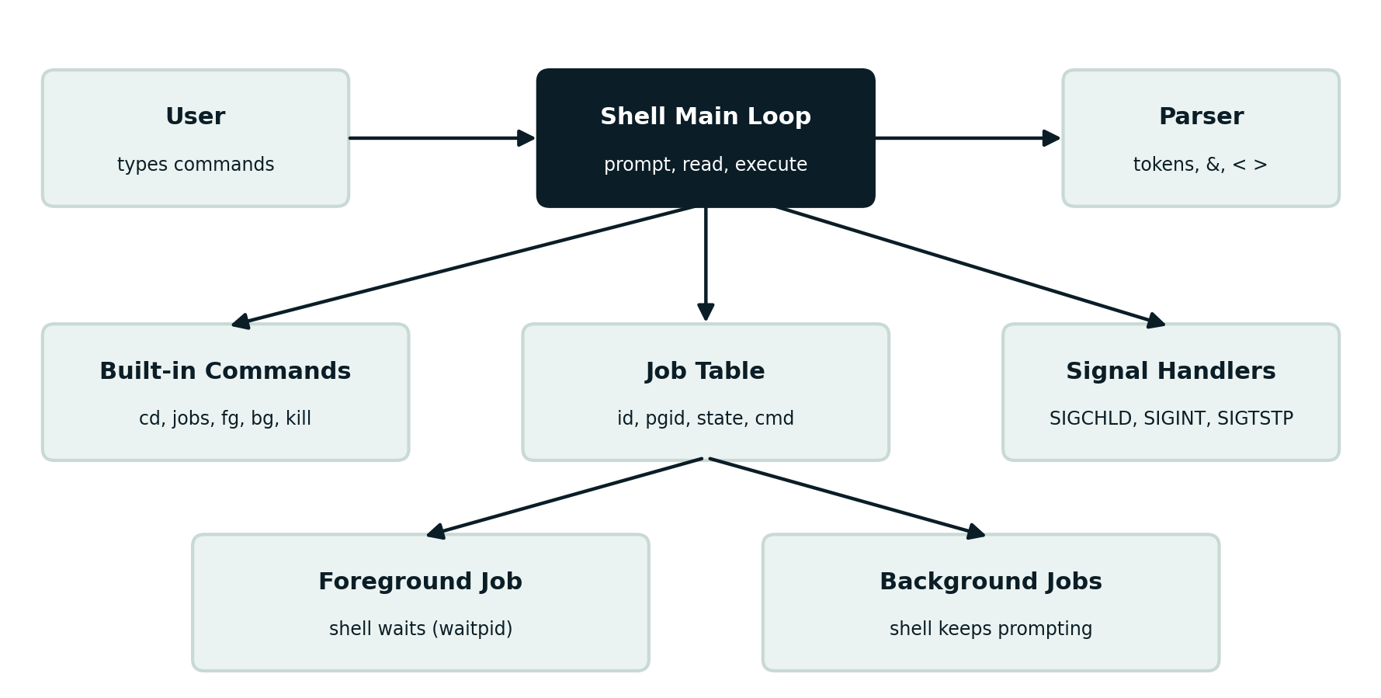
Figure 4.1: Architecture of the Mini Linux Shell

4.1 Shell Main Loop and Parser
The main loop prints the prompt, reads a line and passes it to the parser. The parser splits the line into tokens, builds the argument array (argv) for the program, and checks whether the last token is & so that the job can be marked as a background job. Input and output redirection symbols (< and >) are also recognised. Empty lines are ignored and the loop continues.
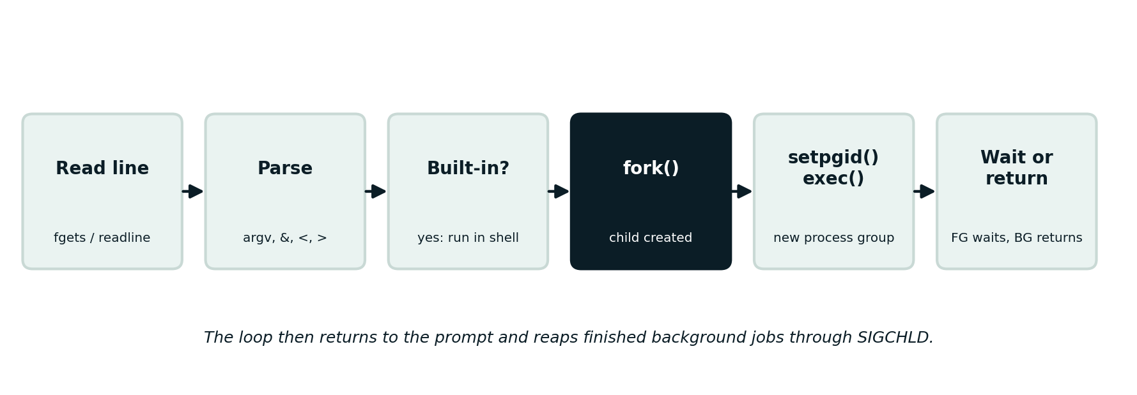
Figure 4.2: Command execution flow

4.2 Built-in Commands
Some commands must run inside the shell process itself. For example, cd has to change the shell's own working directory, so it cannot run in a child. The built-ins are cd, exit, jobs, fg, bg, kill and help. Anything else is treated as an external program and launched with fork() and exec().

4.3 Job Table and Job Control
Each job started by the shell gets an entry in the job table. The entry stores the job number, the process group ID, the state (Running, Stopped or Done), whether it is a foreground or background job, and the original command text. The child calls setpgid(0, 0) so that it leads its own process group, and the parent repeats the call to avoid a race. For a foreground job the shell gives the terminal to the job with tcsetpgrp() and takes it back when the job ends or stops.
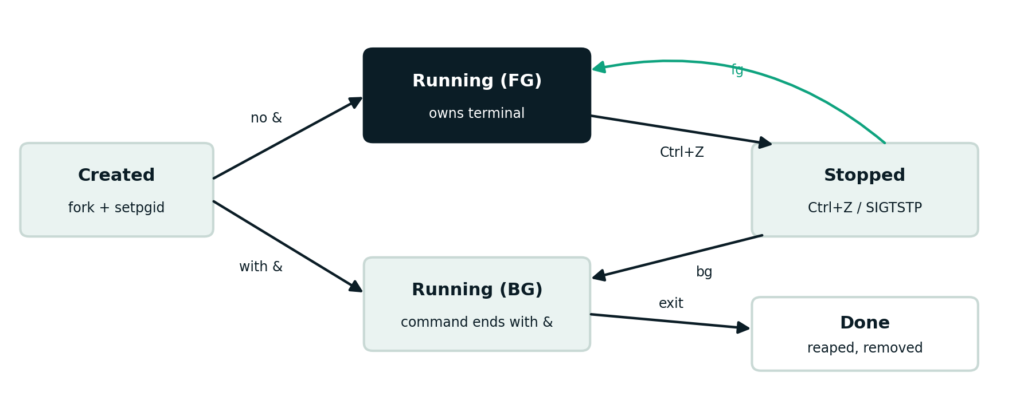
Figure 4.3: Job state transitions

4.4 Signal Handling
The shell ignores SIGINT and SIGTSTP for itself so that Ctrl+C and Ctrl+Z affect only the foreground job. Children restore the default handlers before calling exec(). A SIGCHLD handler calls waitpid() with WNOHANG, WUNTRACED and WCONTINUED to learn when a background job exits, stops or continues, and updates the job table without blocking the prompt. Signal masks are used around table updates to avoid race conditions.

4.5 Working Methodology
- The shell starts, installs its signal handlers and prints the prompt.
- The user types a command and presses Enter.
- The parser creates argv and detects the & operator.
- If the command is a built-in, the shell runs it directly.
- Otherwise the shell calls fork() to create a child process.
- The child calls setpgid(), restores default signals and runs the program with execvp().
- For a foreground job, the shell gives it the terminal and waits using waitpid().
- For a background job, the shell adds it to the job table, prints its job number and PID, and returns to the prompt.
- When a background job ends, SIGCHLD lets the shell reap it and mark it Done; jobs and the next prompt report it.
- The user can list, suspend, resume or kill jobs until typing exit.

4.6 Implementation Modules
Module | File | Responsibility
Main loop | shell.c | Prompt, read input, dispatch commands, shutdown
Parser | parser.c | Tokenise input, detect &, handle < and >
Executor | executor.c | fork, setpgid, execvp, foreground wait
Built-ins | builtins.c | cd, exit, jobs, fg, bg, kill, help
Job table | jobs.c | Add, find, update and remove jobs
Signals | signals.c | SIGCHLD, SIGINT and SIGTSTP handling

A simplified outline of the core execution logic is shown below.
pid = fork();
if (pid == 0) { /* child */
setpgid(0, 0); /* own process group */
signal(SIGINT, SIG_DFL); signal(SIGTSTP, SIG_DFL);
execvp(argv[0], argv); _exit(127);
}
setpgid(pid, pid); /* parent repeats it */
job = add_job(pid, cmdline, background);
if (!background) {
tcsetpgrp(STDIN_FILENO, pid);
waitpid(-pid, &status, WUNTRACED);
tcsetpgrp(STDIN_FILENO, getpgrp());
} else printf("[%d] %d\n", job->id, pid);

CHAPTER - 5 TESTING AND VALIDATION
The following test cases are used to evaluate the shell. Zombie processes can be checked with ps while a job finishes, and system calls can be observed with strace.
Test | Expected result
Run a foreground command (ls) | Output is shown and the prompt returns after the command ends
Run a background command (sleep 30 &) | Job number and PID are printed and the prompt returns immediately
Run jobs | Background job is listed as Running with its PID
Press Ctrl+Z on a foreground job | Job stops and is listed as Stopped
Run bg %n on a stopped job | Job resumes in the background
Run fg %n | Job returns to the foreground and the shell waits
Press Ctrl+C in the shell | Only the foreground job is interrupted; the shell keeps running
Run kill %n | Job is terminated and removed from the table
Let a background job finish | Job is reaped and reported Done; no zombie remains
Run cd and exit | Directory changes; shell exits cleanly

5.1 Screenshots of Test Execution
[ Insert screenshot here ]
Screenshot of the shell prompt running a foreground command
Figure 5.1: Foreground command execution
[ Insert screenshot here ]
Screenshot of sleep 30 & showing the job number and PID, then the jobs output
Figure 5.2: Background job started and listed with jobs
[ Insert screenshot here ]
Screenshot of Ctrl+Z followed by jobs showing Stopped, then bg and fg
Figure 5.3: Suspending and resuming a job with Ctrl+Z, bg and fg
[ Insert screenshot here ]
Screenshot of kill %n and a finished job reported Done
Figure 5.4: Killing a job and reaping a finished job
[ Insert screenshot here ]
Screenshot of ps output confirming no zombie (Z) processes remain
Figure 5.5: No zombie processes after background jobs finish

CHAPTER - 6 RESULTS
The shell is expected to execute foreground commands normally, run commands with & in the background while returning the prompt at once, and show every job in the jobs listing with the correct state. Suspending with Ctrl+Z and resuming with bg or fg should change the job state accordingly, and finished background jobs should be reaped without leaving zombie processes. Add the observed output and screenshots from your own test runs below before final submission.
[ Insert screenshot here ]
Screenshot of a complete session: background job, jobs, Ctrl+Z, bg, fg, kill
Figure 6.1: Sample shell session showing job management
[ Insert screenshot here ]
Screenshot of ps / strace output confirming correct process and signal behaviour
Figure 6.2: Process-level verification

CHAPTER - 7 LIMITATIONS
- The current version supports simple commands and does not implement full pipelines (|) or command chaining (&&, ||).
- Shell scripting, variables, wildcards and command history are not included.
- Input and output redirection support is basic.
- The job table has a fixed maximum size.
- The shell is a learning project and not a replacement for bash or zsh.

CHAPTER - 8 FUTURE ENHANCEMENTS
- Add pipelines so that several processes can be connected with |.
- Add command history and line editing using the readline library.
- Support environment variables, wildcard expansion and quoting.
- Add a startup configuration file and a customisable prompt.
- Support scripts and conditional execution with && and ||.
- Add disown, wait and notifications when a background job finishes.
- Add automated tests for job control behaviour.

CHAPTER - 9 TEAM CONTRIBUTIONS
- M. Laasya Sri (2520090196): shell main loop, command parser, fork/exec execution and built-in commands.
- M. Rajini (2520090197): job table, signal handling and the fg, bg and kill logic.
- K. Ramya (2520090213): test cases, testing and validation, documentation and presentation.

CHAPTER - 10 CONCLUSION
The Mini Linux Shell with Background Job Management shows how a shell is built from a small number of operating system mechanisms. fork(), exec() and waitpid() create and run processes, process groups and tcsetpgrp() decide who owns the terminal, and signals allow jobs to be interrupted, suspended, resumed and reaped.
By adding background execution and a job table, the project turns a simple command runner into a usable interactive shell and gives a hands-on understanding of process management, signal handling and zombie prevention in Linux. The design can be extended with pipelines, history and scripting to move closer to a full-featured shell.

